**Testing Scenarios**

In order to ensure the functionality, security, and usability of our social media platform, we have developed a comprehensive set of testing scenarios. These scenarios cover a range of features and functionalities, including account creation, login, messaging, following, posting, viewing others' posts, updating profiles, and file handling for storing user data. We use file handling as a secure and efficient way to store user data, and it is essential that this functionality is thoroughly tested. Each scenario is carefully designed to test a specific feature or functionality, and is executed using a combination of manual and automated testing methods. Through rigorous testing, we aim to identify and resolve any issues or bugs in the platform, and to provide a smooth and seamless experience for our users. By testing these scenarios thoroughly, we are confident that our social media platform will provide a secure, user-friendly, and engaging experience for all of our users.

**Note:-** We already created account for [prince@gmail.com](mailto:prince@gmail.com), [anup@gmail.com](mailto:anup@gmail.com), [patel@gmail.com](mailto:patel@gmail.com), sandy@gmail.com,scand@gmail.com.

**Step1:-**  When we execute this program, then It give 3 options.

Option 1 for create account, option 2 for login, option 3 for exit. If we give any other value rather than 1, 2, 3 in console then it shows “enter valid option”.

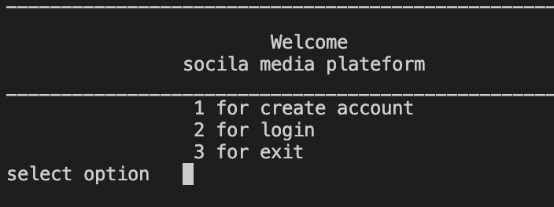

**Step2:-**  We entered 1 for create account. Then program asked for email Id. We give ‘prince@gmail.com’. Then it is showing that this email Id already exist.

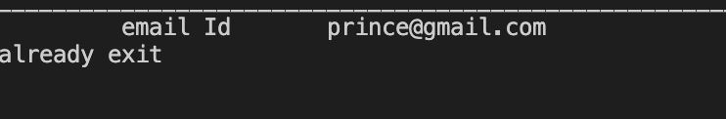

**Step3:-** Then we entered ‘prcaz’, then it is showing that invalid email Id. In this program valid email Id is that who contains ‘@gmail.com’ in last.

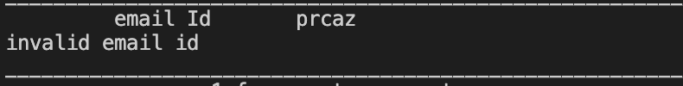

**Step4:-**  So, we entered a valid email Id ‘kumar@gmail.com’. Then further program asked password, name, phone number and DOB. Then it give 2 option, either your account is private or public.

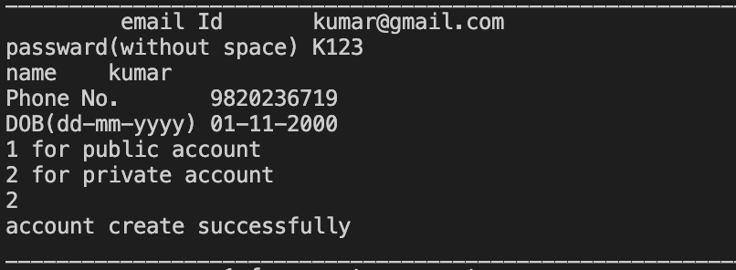

**Step5:-**  Then again asked same thing, now this time we login into ‘prince@gmail.com’.

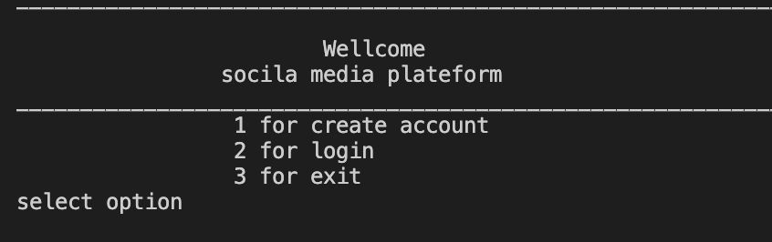

**Step6:-** Here if we give invalid email id or the email Id that doesn’t have account yet while login, then it show error.

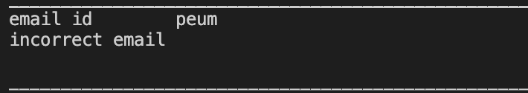

**Step7:-** Then after valid email Id, which have already account, then it asked for password. If it is incorrect then it shows ‘incorrect password’ and again asked for valid password.

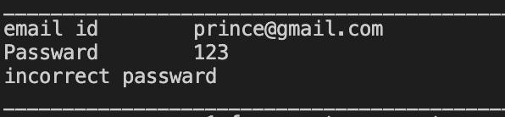

**Step8:-**  After successfully login, it shows many option as given in figure. We check all option one by one.

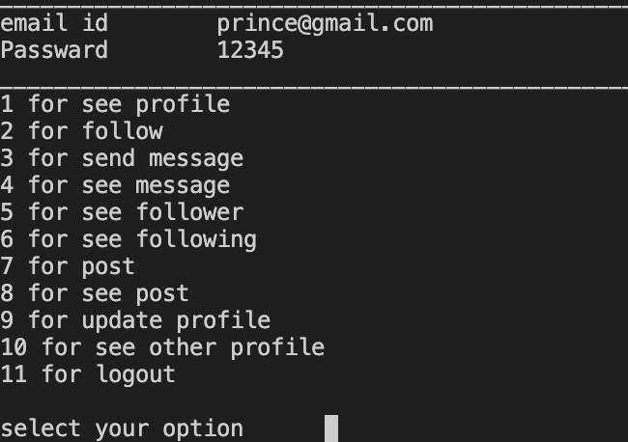

**Step9:-**  Then we select option 1 for see profile, and it show all details of user, like name, phone no, DOB, no of followers and following.

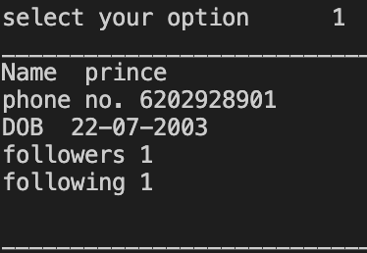

**Step10:-**  Then we select option 2 for follow someone, whose account exist.

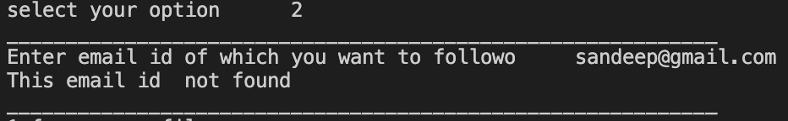

**Step11:-** If we give email Id, which is not exist, then it shows ‘This email id not found’ and again asked for email id. First we give ‘sandeep@gmail.com’, it shows ‘This email Id not found’, then we give ‘patel@gmail.com’. Since, this email Id already exist, so it shows ‘successfully following’.

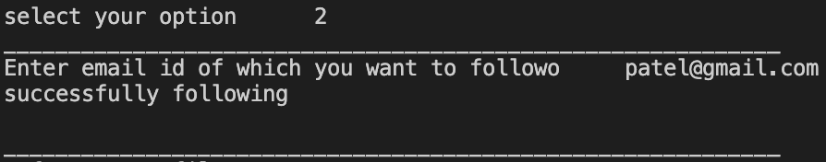

**Step12:-** Now, we select option 3 for sending message.

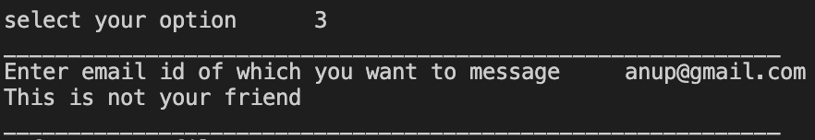

**Step13:-** Here we see that ‘[anup@gmail.com](mailto:anup@gmail.com)’ is valid id but this user not follow/friend, so this user can’t send message. So, he message ‘hello’ to [patel@gmail.com](mailto:patel@gmail.com) because he follow this user id. We cross check this at

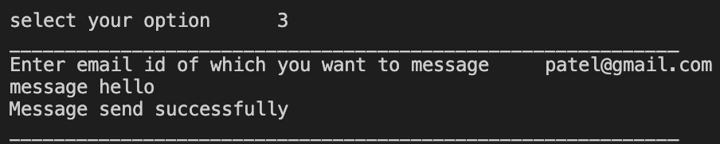

**Step14:-** Now, we select option 4, to see all message. And it shows all message, that to whom we message and from whom we get message.

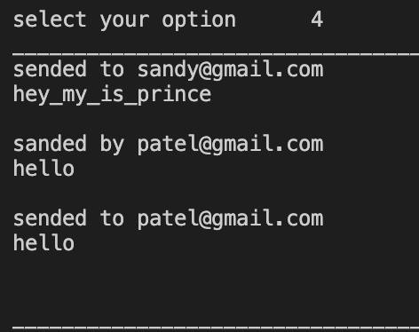

**Step15:-** Now, we select option 5 and 6, to see follower and following.



**Follower-**

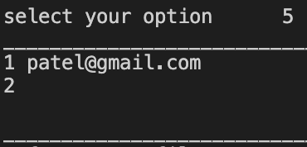

**Following-**

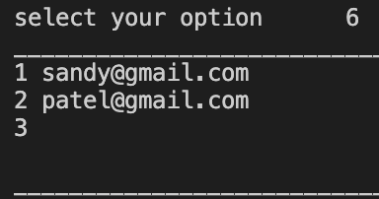

**Step16:-** Now, we select option 7. In this, user Id posted ‘I_am_student_of_computer_science’. And this shown to all user, who follow this user Id. We can check . We also give image URL.

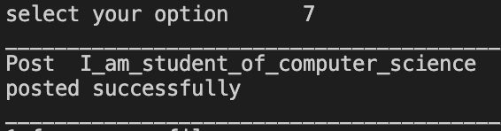

**Step17:-** Now, we select option 7. We can see our post also as well as post of those user Id, which following this user Id.

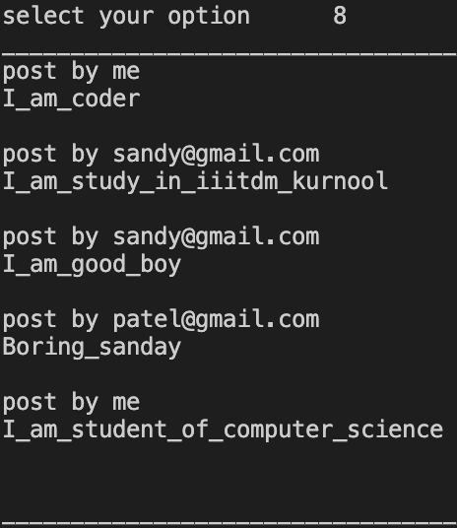

**Step18:-** Now, we select option 9 for update the file. In this we can only update name, phone number, DOB.



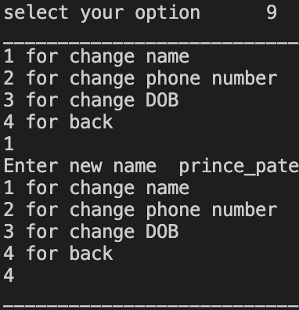

**Step19:-** In this, 4 option will be given as shown. And we can update and cross check by seeing profile as shown below.

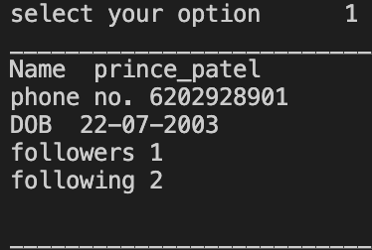

**Step 20:-** Now, we select option 10, for see others profile. In this we only see details either follow user Id, following user Id or public account user Id. We can’t see details private account those aren’t follow. We can see in given screen shot also. We can’t see details ‘kumar@gmail.com’ as it is private account. But we can see details of ‘sandy@gmail.com’ , as this user Id follow ‘sandy@gmail.com’.

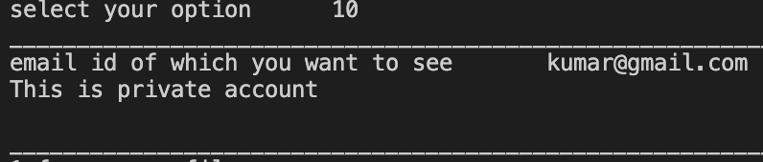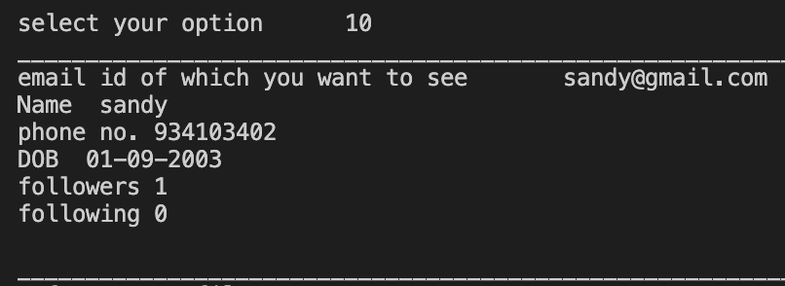

**Step21:-** As we check all option, so now we select option 11 for log out.

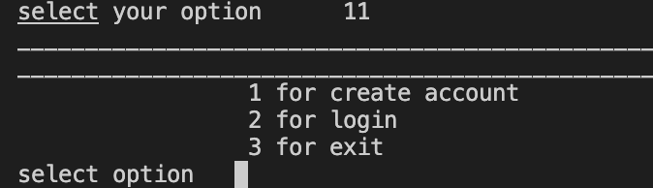

**Step22:-** Now, we login another account that is ‘patel@gmail.com’ because earlier user Id ‘prince@gmail.com’ message to ‘patel@gmail.com’ and also ‘prince@gmail.com’ followed by ‘patel@gmail.com’. So, we can cross check message and post.

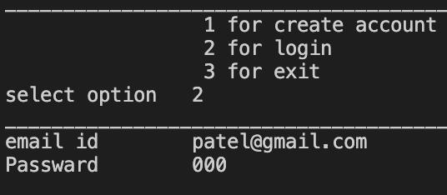

**Step23:-** As we can clearly see that post by ‘prince@gmail.com’. So, if user A follow user B, then user A can see post of user B.

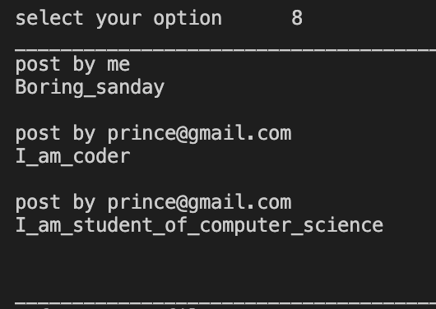

**Step24:-** As we can clearly see that message by ‘prince@gmail.com’.

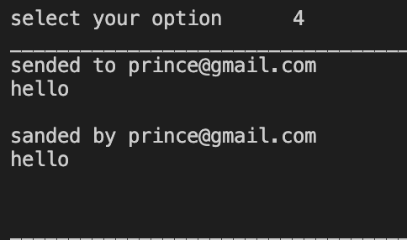

**Step25:-** Now, selecting option 11 to log out and after that we select option 3 to exit the program.

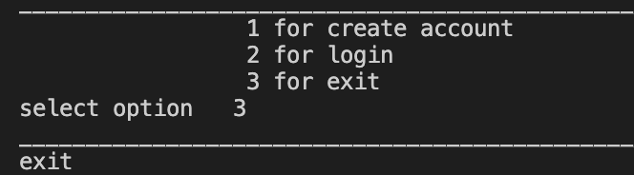

In conclusion, our testing scenarios for the social media platform are designed to ensure that our users have a seamless and secure experience. We are committed to delivering a high-quality product that meets the needs of our users and exceeds their expectations. By thoroughly testing each feature and functionality, we aim to identify and address any issues or bugs, and to provide a user-friendly and engaging platform that fosters meaningful connections and interactions. We will continue to iterate and improve our platform based on user feedback and ongoing testing, and are confident that our social media platform will be a valuable addition to the social media landscape.

**Thank You**